RESUME

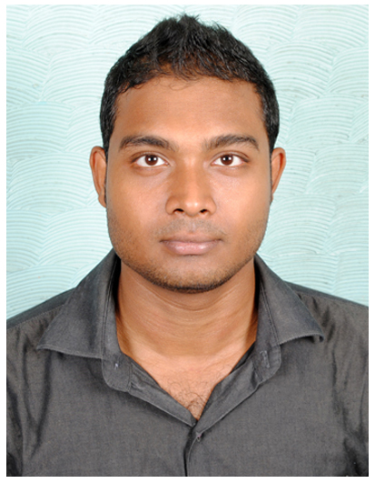  TAMAL KUMAR DUTTA  Personal Data:  Father’s Name : Mr. Tapan Kr Dutta  Date of Birth : 05.07.1988  Sex : Male  Nationality : Indian  Marital Status : Married  Present Address:  AH-64, THAKUR BARI LANE  16 FEET MORE, KESTOUR  KOLKATA-700101  Permanent Address:  SISHUBAGAN, RANIGANJ  P.N MALIA ROAD  BURDWAN WEST BENGAL  713347  Contact Numbers:  +91-9563953720/9681553720  Email ID:  tamalkumardutta.rng@gmail.com | Career Objective  Work to the best of my potential and contribute maximum to organizational goals with continued development of personal and professional skills.  Educational Profile  Degree : M.B.A  Discipline : Marketing  CGPA : 6.5  Institution :Camellia School of Business Management.  University : West Bengal University & Technology, Kolkata  Course : B.B.A(Hons)  Discipline :Marketing  Per. of Marks : 55%  Institution :Michael Madhusudan Memorial Collage  Board : Burdwan University(B.U)  Course : 12 th  Discipline : Arts  Per. of Marks : 62%  Institution : Searsole Raj High School  Board : WBBSE  Course : 10 th  Per. of Marks : 57%  Institution : Searsole Raj High School  Board : WBCHSE
Work experience
Organization: Ola Cabs
Designation: Business Development Executive
Experience: 13 Months
Job Description:
Visit Drivers and Taxi stand also.
Attachment of new car.
Marketing and Promotional activities.

Organization: Opton Infocom Pvt. Ltd
Designation: Marketing Executive
Experience: 1 Year
Job Description:
Promote JUMBODIUM.COM (Online School Admission Process system).
Visit new school on daily basis.
Talk with the principal and discuss how it works.
Register New School.

Organization: Camellia Group
Designation: Marketing Executive
Experience: 8 Months
Job Description:
Visit New Organization.
Banquet Selling And Making deal with Tours & Travels Company.
Club Membership selling.

Strength
- Quick learner, good initiator.
- Strong will power.
- Good Analytical & Problem Solving Skills.
- Team Player and Coordination Skills.

Computer skills
- MS OFFICE
- OPERATING SYSTEM : WIN XP, WIN VISTA, WIN 7.

Languages Known
- BENGALI
- ENGLISH
- HINDI

Interests
- Listening to music
- Surfing Internet

Declaration
I hereby declare that all the data and information provided above are true and correct to the best of my knowledge and I hold responsible myself for any irregularities if found.

DATE:
TAMAL KUMAR DUTTA Signature

